

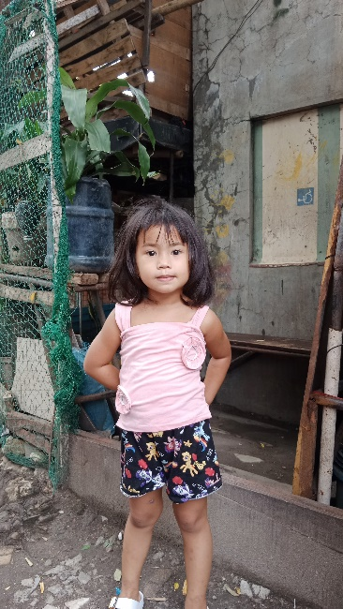**OIKOS HELPING HAND LEARNING CENTER**

**Name-** Zia L. Sarino

**Gender**-Female

**Date** **of** **Birth**- May 1, 2019

**Weight**- Under Nourished | **Neutral** | Above Average

**Daily** **Meals**- 1 | 2 | **3** | 4 | 5 | More

**Health** **Issues**- **No** /Yes

**Siblings** – **1** | 2| 3 | 4 | 5|6 |7 |8 |9 |10|None

**Address-** Villa Monique Home Las Pinas City

**Correspondence** **Address**- Villa Monique Home Las Pinas City

**House** (**building** **materials**) - Concrete | **Wood** | Cardboards | Mixed Debris | Others

**House** **Lease**-Owned | Rental| Share| Squatter | Others-**free**

**Neighbourhood** **Community** **Risk**- No Risk | **Low Risk** | Mid Risk | High Risk

Brief Report-

Zia is four years old and has a sister who is now studying in secondary school. Her father worked in the meat shop for 13 years. And because of this, the owner gives them vacant land to live on, and they will be the ones to build the house. His father earns 12,000 monthly and sometimes works sideline as a carpenter to earn some money. Her father works hard to provide for their needs. Because every month they pay 1,300 for water and 570 for electricity. The mother is just a housewife and looks after her children.

So for them to have the scholarship is a great help, because they will be given free education and quality learning for their child.