

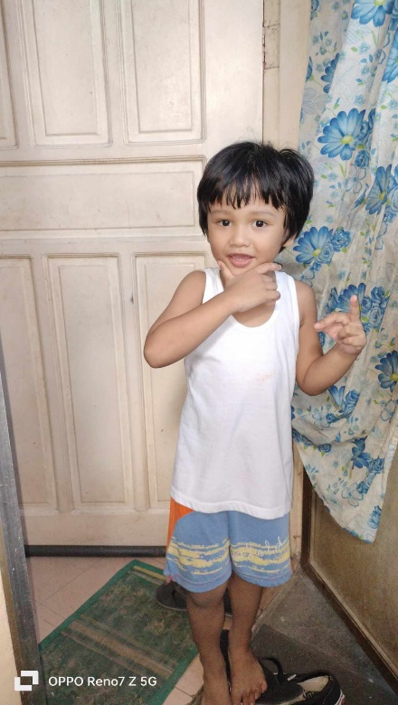OIKOS HELPING HAND LEARNING CENTER

**Name:** Yohan Kinley F. Cheng

**Gender**: Male

**Date** **of** **Birth**: July 6, 2019

**Weight**- Under Nourished | **Neutral** | Above Average

**Daily** **Meals**- 1 | **2** | 3 | 4 | 5 | More

**Health** **Issues**- No / **Yes**

**Siblings** – 1 | 2 | 3| 4 | 5 |6 |7 |8 |9 |10|**None**

**Address:** F40 Berago St. Dela Cruz Compound Pamplona III Las Piñas City

**Correspondence** **Address**: F40 Berago St. Dela Cruz Compound Pamplona III Las Piñas City

**House** (**building** **materials**) **- Concrete** | Wood | Cardboards | Mixed Debris | Others

**House** **Lease**- Owned | **Rental** | **Share** | Squatter | others

**Neighbourhood** **Community** **Risk**- No Risk | **Low Risk** | Mid Risk | High Risk

**Brief Report:**

Yohan is an only child, her mother is in a BPO company. His parents are still in a relationship but live separately. They are renting a house that amounts to 6,000 pesos a month, but their Auntie of Yohan pays for it. They are five people in the house, including the grandparents of Yohan who takes care of him. His mother’s salary is 18,000 monthly; she pays 3,000 pesos for the monthly electric bill and 400-500 pesos for the water bill. She also provides for their daily needs. The father of Yohan gives allowance when his mother is asking for it or when needed. His parents live separately because the place is too small. Yohan was diagnosed with G6PD Deficiency, a genetic disorder that affects red blood cells, which carry oxygen from the lungs to tissue throughout the body. He needs to avoid food with beans.