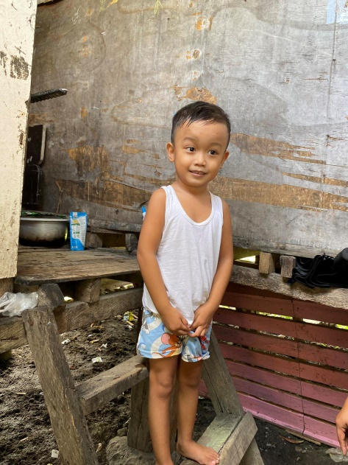OIKOS HELPING HAND LEARNING CENTER

**Name: Raven D. Real**

**Gender**: Male

**Date** **of** **Birth**: February 9, 2019

**Weight**- Under Nourished | **Neutral** | Above Average

**Daily** **Meals**- 1 |2 | **3** | 4 | 5 | More

**Health** **Issues**- No / Yes

**Siblings** – **1** | 2 | 3| 4 | 5 |6 |7 |8 |9 |10|None

**Address:** 12B Kaimito St. Verdant Acres Pamplona III Las Piñas City

**Correspondence** **Address**: 12B Kaimito St. Verdant Acres Pamplona III Las Piñas City

**House** (**building** **materials**) - Concrete | **Wood** | Cardboards | Mixed Debris | Others

**House** **Lease**- Owned |Rental | Share | Squatter | **others-free**

**Neighbourhood** **Community** **Risk**- No Risk | Low Risk | **Mid Risk** | High Risk

**Brief Report:**

Raven has one sibling, his father is a grab driver (food delivery). Every day his father takes home 800 pesos and that is where they get their daily needs. His mother has no work, only his father is the one who provides for their needs. Since they are caretakers they don’t pay for the house. For their water bill, they pay a minimum of 500 pesos per month and they get water outside. For the electric bill, they share 1,000 pesos monthly. His sister is Mitchelkieh Dasig, a former Edufund Scholar. The mother decided to stop the scholarship of Mitchielkieh because when Raven was still months old she breastfeed him and that was during the pandemic the school was very strict for the people who come in and out of the school. When the mother needs to breastfeed she must go out and during duty they must stay inside the school until they finished the time. But now that Raven already grows up, she can do the parent-scholar responsibilities without worrying.