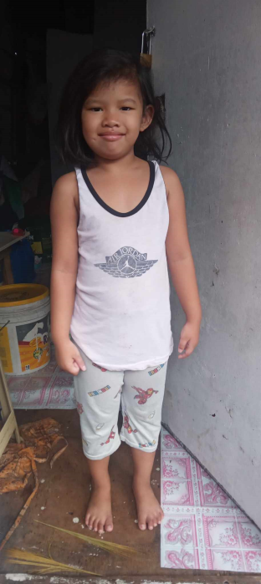

OIKOS HELPING HAND LEARNING CENTER

**Name-** Maria Faith Tobias

**Gender**-Female

**Date** **of** **Birth**- August 15, 2018

**Weight**- Under Nourished | **Neutral** | Above Average

**Daily** **Meals**- 1 | 2 | **3** | 4 | 5 | More

**Health** **Issues**- **No** / Yes

**Siblings** –1| 2 | 3 | 4| 5 |6 |7 |8 |9 |10|**None**

**Address-** #25 Monique Compound Villa Cristina Subd Pamplona III Las Pinas City

**Correspondence** **Address**- #25 Monique Compound Villa Cristina Subd Pamplona III Las Pinas City

**House** (**building** **materials**) - **Concrete** **|** **Wood** | Cardboards | Mixed Debris | Others

**House** **Lease**- Owned | **Rental** | Share | Squatter | Others

**Neighbourhood** **Community** **Risk**- No Risk | Low Risk | **Mid Risk** | High Risk

Brief Report-

Maria Faith was adopted by her auntie, but her father still living with them. He still give support to her, her father’s work is construction. His salary is not consistent, because he is on call. Sometimes he earns 500-1,000. Her auntie does the laundry and earns 3,500 monthly. Now they rent two houses due to her auntie was diagnosed with Tuberculosis, she need to be separated from them. They rent 2,800 for one house then 1,200 pesos for another house. For the water, they still get it outside. For both houses they pay 360 pesos, 1,500 for electricity.