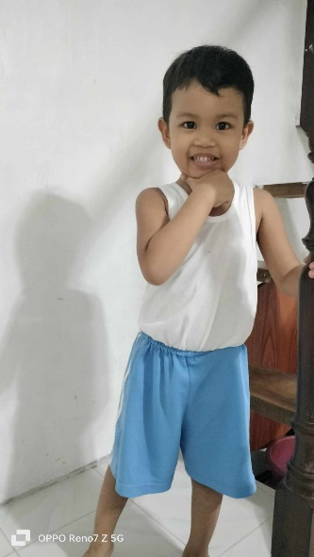OIKOS HELPING HAND LEARNING CENTER

**Name: King Thorin B. Oñez**

**Gender**: Male

**Date** **of** **Birth**: September 20, 2019

**Weight**- Under Nourished | **Neutral** | Above Average

**Daily** **Meals**- 1 |2 | **3** | 4 | 5 | More

**Health** **Issues**- No / Yes

**Siblings** – 1 | **2** | 3| 4 | 5 |6 |7 |8 |9 |10|None

**Address:** De Castro 2nd St. Ligas I Bacoor Cavite

**Correspondence** **Address**: De Castro 2nd St. Ligas I Bacoor Cavite

**House** (**building** **materials**) - Concrete | **Wood** | Cardboards | Mixed Debris | Others

**House** **Lease**- Owned | **Rental** | Share | Squatter | Others

**Neighbourhood** **Community** **Risk**- No Risk | **Low Risk** | Mid Risk | High Risk

**Brief Report:**

King Thorin has two half-brothers from his father’s side. They are from the first family, the two are still studying. His father is working as a driver, they deliver medicine from different drugstores. He earns 20-24,000 pesos a month. They are renting a house for 4,000 pesos. They pay 700 pesos for the water bill and 700 pesos for the electric bill. Monthly his father gives an allowance to his siblings, of 6000 pesos. They are spending 300 pesos for daily expenses. So only the father is working, and the only source. The mother needs to budget the money.

King Thorin sometimes experiences high fever combulsion which occurs in young children. He is triggered by a fever typically above 101 degrees Fahrenheit. So the mother is closely guarded about his health.