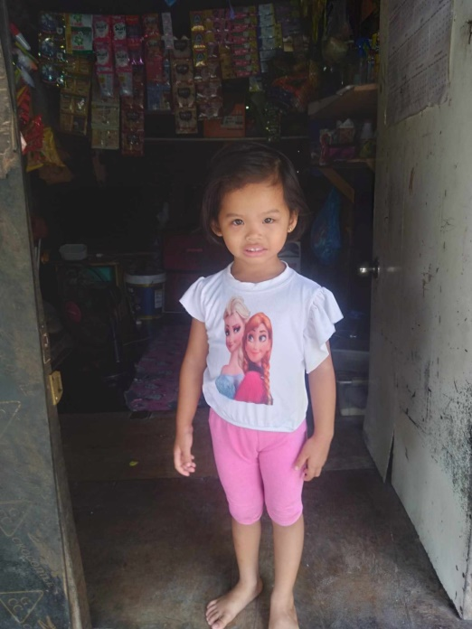OIKOS HELPING HAND LEARNING CENTER

**Name: Kiara B. Lequigan**

**Gender**: Female

**Date** **of** **Birth**: October 2, 2019

**Weight**- Under Nourished | **Neutral** | Above Average

**Daily** **Meals**- 1 |2 | **3** | 4 | 5 | More

**Health** **Issues**- **No** / Yes

**Siblings** – **1** | 2 | 3| 4 | 5 |6 |7 |8 |9 |10|None

**Address:** Ligas St. Manuela 4E Pamplona III Las Piñas City

**Correspondence** **Address**: Ligas St. Manuela 4E Pamplona III Las Piñas City

**House** (**building** **materials**) - Concrete | **Wood** | Cardboards | Mixed Debris | Others

**House** **Lease**- Owned |Rental | Share | Squatter | **Others-Free**

**Neighbourhood** **Community** **Risk**- No Risk | **Low Risk** | Mid Risk | High Risk

Brief Report:

Kiara has one sibling; her father is working as a welder for about 15 years. His salary is 600 pesos per day. His boss is buying a lot/lawn and it will turn to a townhouse or building but while the lot is not yet under construction they can build a house there and live for free. When the boss is about to construct a building they will move to another place where their boss is also the owner. Monthly they share 300 pesos for the water bill and 1,000-1,200 pesos for the electric bill. Her mother has small store, to sustain their daily needs.