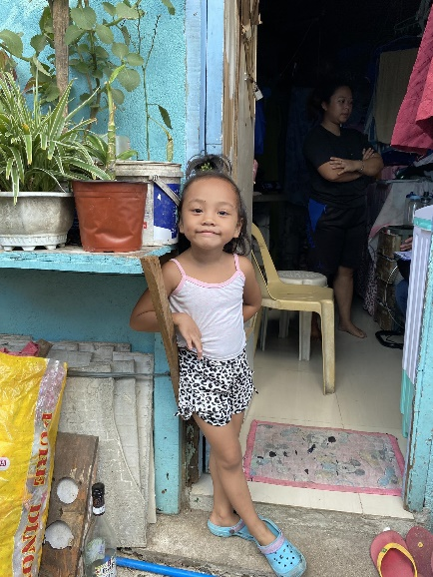
OIKOS HELPING HAND LEARNING CENTER

Name- Frensh A. Estanislao
Gender-Female
Date of Birth- March 11, 2019
Weight- Under Nourished | Neutral | Above Average
Daily Meals- 1 | 2 | 3 | 4 | 5 | More
Health Issues- No / Yes
Siblings – 1 | 2 | 3 | 4 | 5 |6 |7 |8 |9 |10|None

Address- Blk 3 Lot 21 Satima Compound Talon Dos Las Pinas City
Correspondence Address- Blk 3 Lot 21 Satima Compound Talon Dos Las Pinas City
House (building materials) - Concrete | Wood | Cardboards | Mixed Debris | Others
House Lease- Owned | Rental | Share | Squatter | Others-free
Neighbourhood Community Risk- No Risk | Low Risk | Mid Risk | High Risk

Brief Report-
Frensh is the only child. They live with her grandparents. The space given to them is small, and where they sit is also the same place where they sleep. So they just endured instead of renting a house, because it’s quite costly when renting a place and they cannot afford it. The father works as a delivery rider in Cavite, so his salary is a provincial rate (470.00), he just started last July 24, 2023. And her mother do some sideline like manicures and pedicure earning 1,000 monthly at least somehow it helps to buy food. Their monthly bill for water is 500.00 and for electricity is 500.00.

