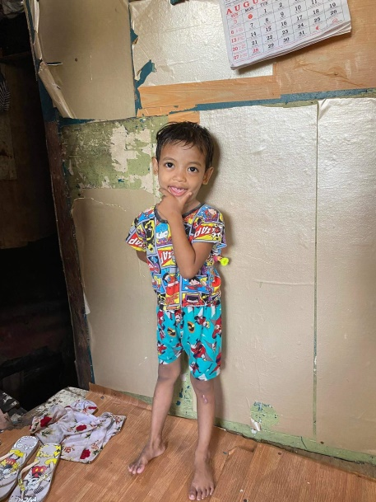OIKOS HELPING HAND LEARNING CENTER

**Name: Daniel B. Diola**

**Gender**: Male

**Date** **of** **Birth**: June 24, 2019

**Weight**- Under Nourished | **Neutral** | Above Average

**Daily** **Meals**- 1 |2 | **3** | 4 | 5 | More

**Health** **Issues**- **No** / Yes

**Siblings** – 1 | 2 | 3| **4** | 5 |6 |7 |8 |9 |10|None

**Address:** 19 Guijo St. Manuela 4D Pamplona III Las Piñas City

**Correspondence** **Address**: 19 Guijo St. Manuela 4D Pamplona III Las Piñas City

**House** (**building** **materials**) - Concrete | **Wood** | Cardboards | Mixed Debris | Others

**House** **Lease**- Owned |Rental | Share | Squatter | **Others-Free**

**Neighborhood** **Community** **Risk**- No Risk | Low Risk | Mid Risk | **High Risk**

Brief Report:

Daniel has 4 siblings, his father as of now has no work. His mother is working as street sweeper. She earns 7,500 monthly; they are paying 500 pesos for the water they are only getting outside. They don’t have electricity from the time they live there. Their place is not safe for the children, before you reach their house you have to climb two steep stairs. One of his brothers is going the convenience store to open and close the door for people so he can receive money from them. In that way his brother gives some money to her mother so they can buy food.