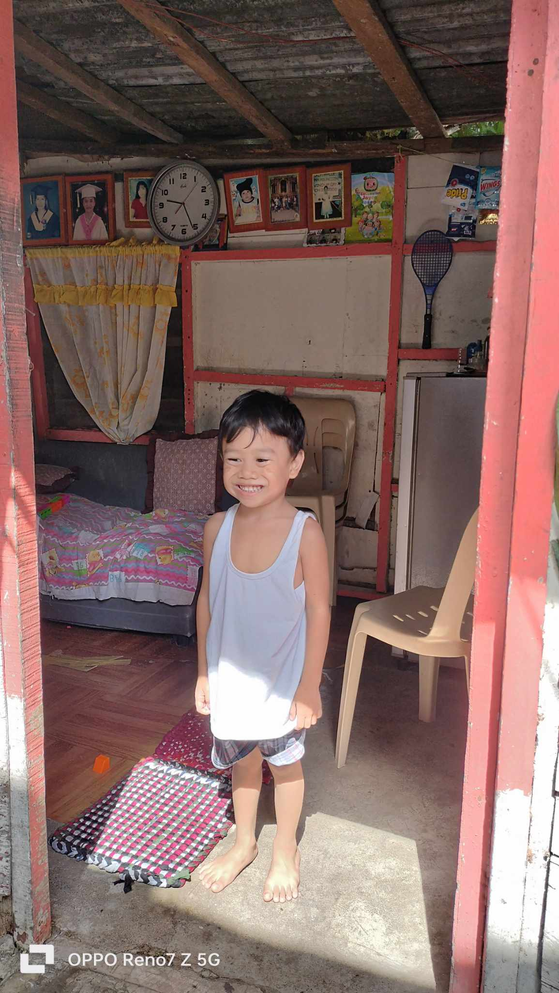

OIKOS HELPING HAND LEARNING CENTER

**Name-** Clyde Jhon A. Macaambac

**Gender**-Male

**Date** **of** **Birth**- December 29, 2018

**Weight**- **Under Nourished** | Neutral| Above Average

**Daily** **Meals**- 1 | 2 | **3** | 4 | 5 | More

**Health** **Issues**- No/ **Yes**

**Siblings** –1| 2| 3 | 4| 5 |6 |7 |8 |9 |10|**None**

**Address-** Kasoy St. Verdant Acres Pamplona Tres Las Piñas City

**Correspondence** **Address**- Kasoy St. Verdant Acres Pamplona Tres Las Piñas City

**House** (**building** **materials**) - Concrete | **Wood** | Cardboards | Mixed Debris | Others

**House** **Lease**- Owned| **Rental** | Share | Squatter | Others-free

**Neighbourhood** **Community** **Risk**- No Risk | Low Risk | **Mid Risk** | High Risk

Brief Report-

Clyde Jhon is the youngest. They have 20 years gap with her sister. Her parents said that they did not expect to have a baby. But still, they are grateful to God, because still a blessing. Her sister is now in college taking a course IT(*Information Technology).* Good thing her sister was able to avail of the scholarship. So it’s a great help she doesn’t have to pay for the tuition only for the fare and allowance.

The pandemic affects John’s Socio-emotional development. The mother said that his son has a fear to mingle with other children, and he preferred to stay at home. He is afraid of many things. But thank God now when he brings Clyde Jhon to church and attends Sunday school, he would love to play and make friends with other children.

The father is working as a driver earning 15,000 monthly. Monthly they pay for house rent 1300.00, water bill 800.00 and electricity 1500.