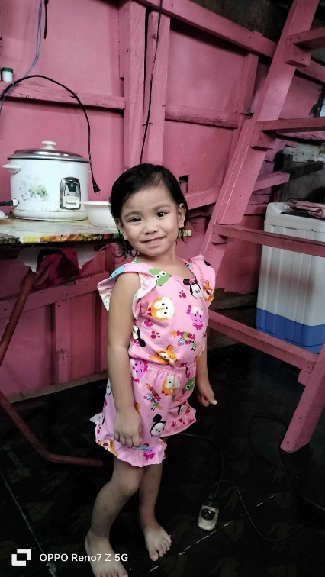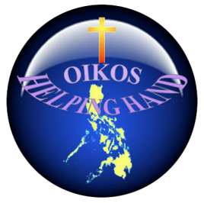

OIKOS HELPING HAND LEARNING CENTER

**Name-** Chesca Marie G. Gulperic

**Gender**-Female

**Date** **of** **Birth**- August 14, 2019

**Weight**- Under Nourished | **Neutral** | Above Average

**Daily** **Meals**- 1 | 2 | **3** | 4 | 5 | More

**Health** **Issues**- **No** / Yes

**Siblings** –1| 2| 3 | **4** | 5|6 |7 |8 |9 |10|None

**Address-** #12 Kaimito St. Verdanr Acres Las Piñas City

**Correspondence** **Address**- #12 Kaimito St. Verdanr Acres Las Piñas City

**House** (**building** **materials**) - **Concrete** | **Wood** | Cardboards | Mixed Debris | Others

**House** **Lease**- **Owned** | Rental| Share | Squatter | Others-free

**Neighbourhood** **Community** **Risk**- No Risk | Low Risk | Mid Risk | High Risk

Brief Report-

Chesca Marie is the youngest in the family. He has 4 siblings; the eldest one has a mental disability. His father is a welder, sometimes a construction or a laborer that earns 5,000 A week His mother is a full-time wife. And she has diabetes and she has to take medicine every day, good thing she can avail of free medicine at the center but if it is not available she needs to buy it at a drug store. So the father has to work hard to sustain the needs of the family. Only the father supports the needs of the family including all the expenses and bills needed to pay. For the water bill they pay 1200.00 per month, electricity is 1900, because the owner collects it’s so high 21 per kWh.

They are living near the river and have no systematic comfort rooms and all the waste directly goes to the river. And their place is prone to flood.