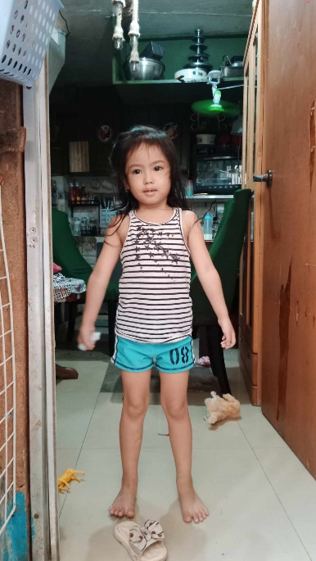

OIKOS HELPING HAND LEARNING CENTER

**Name-** Brianna Aleyah S. Lirazan

**Gender**-Female

**Date** **of** **Birth**- May 1, 2019

**Weight**- Under Nourished | **Neutral** | Above Average

**Daily** **Meals**- 1 | 2 | **3** | 4 | 5 | More

**Health** **Issues**- **No** / Yes

**Siblings** – **1** | 2| 3 | 4 | 5|6 |7 |8 |9 |10|None

**Address-** Villa Monique Homes Cristina Pamplona Tres Las Piñas City

**Correspondence** **Address**- Villa Monique Homes Cristina Pamplona Tres Las Piñas

City

**House** (**building** **materials**) - Concrete | **Wood** | Cardboards | Mixed Debris | Others

**House** **Lease**-Owned| Rental| Share| Squatter | Others-**free**

**Neighbourhood** **Community** **Risk**- No Risk | **Low Risk** | Mid Risk | High Risk

**Brief Report-**

Brianna grew up without her father but still she receive a small amount of financial support. The father is working in a call center. But they are separated (Brianna’s mom). Now Brianna has another sibling, but no support from the father. So Brianna’s mom has to take all the responsibility in providing for their needs. She has to work hard for the sake of her children. She is working in Pogo which earns 20,000 monthly. Sometimes she accommodates side-line work like hair styling and make-up, to add as her source of income. Because most of the expenses and bills are shoulder by her.

The grandmother is working as housekeeping for 2-3 hours, three times a week earning 500 a day.