OIKOS HELPING HAND LEARNING CENTER
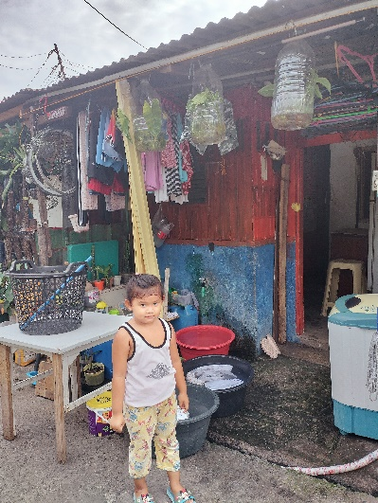

Name- Maria Faith D. Tobias
Gender-Female
Date of Birth- August 15, 2018
Weight- Under Nourished | Neutral | Above Average
Daily Meals- 1 | 2 | 3 | 4 | 5 | More
Health Issues- No / Yes
Siblings – 1 | 2 | 3 | 4 | 5 |6 |7 |8 |9 |10|None

Address- 23 BNT Compound Monique St. Pamplona III Las Pinas City
Correspondence Address- 23 BNT Compound Monique St. Pamplona III Las Pinas City
House (building materials) - Concrete | Wood | Cardboards | Mixed Debris | Others
House Lease- Owned | Rental | Share | Squatter | Others- P1500.00
Neighbourhood Community Risk- No Risk | Low Risk | Mid Risk | High Risk

Brief Report-
Maria Faith is the only child, her mother left them since she was a baby and because of that her auntie adopted her. Her auntie takes care of her and her father, his father’s work is inconsistent sometimes he has work but most of the time he doesn’t have. That’s why all the expenses in their house are shouldered by her auntie. They pay 4,000 pesos for house rental, 300 pesos for water bill and 1,500 for electricity. They only live with her auntie because his father is not able to provide their needs. Now the area where they are living will be renovated by the lot owner. So, they will move to another place but
will still rent for 2,800 pesos. Her auntie earns money by doing the laundry, she earns 3,500 pesos monthly which they are using for their everyday expenses.

