OIKOS HELPING HAND LEARNING CENTER
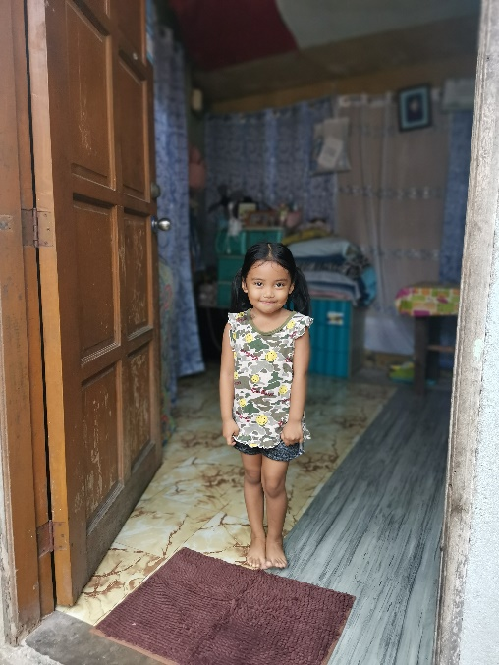

Name- Leozabelle R. Mallari
Gender-Female
Date of Birth- August 17, 2018
Weight- Under Nourished | Neutral | Above Average
Daily Meals- 1 | 2 | 3 | 4 | 5 | More
Health Issues- No / Yes
Siblings – 1 | 2 | 3 | 4 | 5 |6 |7 |8 |9 |10|None

Address- B40 LOT31 South Morning View P5 Timalhan Balsahan Naic Cavite
Correspondence Address- #17 Panay St. Timog Pagkakaisa CAA Pamplona III Las Pinas City
House (building materials) - Concrete | Wood | Cardboards | Mixed Debris | Others
House Lease- Owned | Rental | Share | Squatter | Others-free
Neighbourhood Community Risk- No Risk | Low Risk | Mid Risk | High Risk

Brief Report-
Leozabelle is an only child, his father is working as delivery rider but last month he got into accident and it affects his collar bone. Now he is under therapy for six months, regarding the expenses the company only gave allowance during the first month but now it seems the company doesn’t want to give anymore. To provide their daily needs, the mother sells snacks and earns 725 a day including the capital. That’s a big help for them especially that her father has no work. They are renting a house for 2,000 pesos, 500 pesos for water consumption and 700 for electric consumption. When they are in needs, their relatives that close to them help with the expenses for the mean time.

