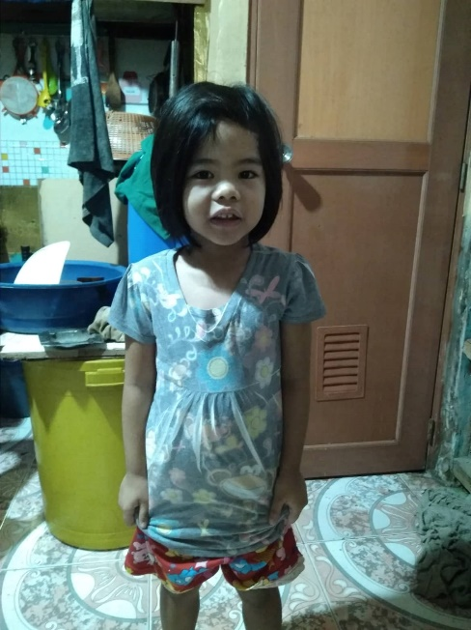
OIKOS HELPING HAND LEARNING CENTER

Name- Leandra Antonette C. Aurelio
Gender-Female
Date of Birth- June 22, 2018
Weight- Under Nourished | Neutral | Above Average
Daily Meals- 1 | 2 | 3 | 4 | 5 | More
Health Issues- No / Yes
Siblings – 1 | 2 | 3 | 4 | 5 |6 |7 |8 |9 |10|None

Address- 1327 Miranda Compound Zapote Las Pinas City
Correspondence Address- 1327 Miranda Compound Zapote Las Pinas City
House (building materials) - Concrete | Wood | Cardboards | Mixed Debris | Others
House Lease- Owned | Rental | Share | Squatter | Others-free
Neighbourhood Community Risk- No Risk | Low Risk | Mid Risk | High Risk

Brief Report-
Leandra is the 2nd child and a 4yr old kid. Her family are living with his grandfather and in that house are 3 families living there that is 9pax overall. Her oldest sibling is studying and now is in grade 9 this year. Her father is a tricycle driver and can drive for 5 days in a week. Her father can earn 2000 pesos a week and this earning they have to pay for the water bill 300 pesos a month, electricity 1500 a month, this earning is insufficient to support all their expenses and needs, so the mother have to get an extra work as a house helper at least once a week and can earn 300 pesos a week. Her extra can also help them for the milk of Leandra cost 1600 a month, additional expenses if this year is getting face to face classes already the oldest child have to support their transportation and allowance which is 400 pesos per week. The scholarship is a very big help for them because of free education and they do not think about the needs of Leandra. And they are grateful because Oikos come to them and offer this kind of opportunity to every family that in need.

