

OIKOS HELPING HAND LEARNING CENTER

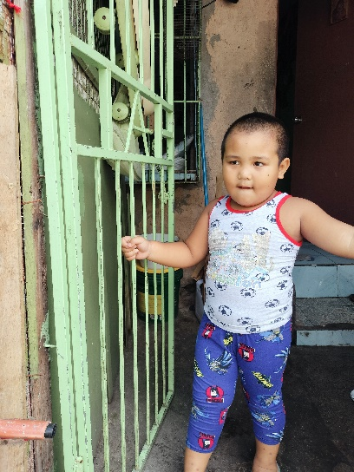

**Name-** John Reniel A. Perez

**Gender**-Male

**Date** **of** **Birth**- August 30, 2018

**Weight**- Under Nourished | **Neutral** | Above Average

**Daily** **Meals**- 1 | 2 | **3** | 4 | 5 | More

**Health** **Issues**- **No** / Yes

**Siblings** –1| **2** | 3 | 4| 5 |6 |7 |8 |9 |10|None

**Address-** B4 L4 Monique St. Villa Cristina Pamplona III Las Pinas City

**Correspondence** **Address**- B4 L4 Monique St. Villa Cristina Pamplona III Las Pinas City

**House** (**building** **materials**) - **Concrete** | Wood | Cardboards | Mixed Debris | Others

**House** **Lease**- Owned | Rental | **Share** | Squatter | Others-free

**Neighbourhood** **Community** **Risk**- No Risk | **Low Risk** | Mid Risk | High Risk

Brief Report-

John Reniel is the eldest child, He has two siblings Renz Perez who is two years old, and His youngest sister Arianne Joy Perez who is 11 months old. His father’s name is Ronilo Perez who graduated from high school and now works as a painter and earns 14,400.00 a month, and his mother Apple Amoroto, graduated from college with a programing course. And she also has an pneumonia which is also the reason why she can’t pass to medical when she applies for a job. As of now she works as a street sweeper and she earns 5,000.00 a month. This Family are living with their grandmother ,three families in the same house. They share electricity bills and the house but the water is separated cost.