

OIKOS HELPING HAND LEARNING CENTER

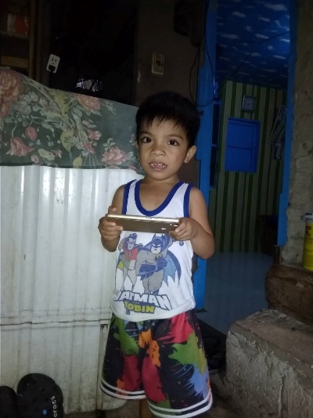

**Name-** CJ D. Dellomas

**Gender**-Male

**Date** **of** **Birth**- September 9, 2018

**Weight**- Under Nourished | **Neutral** | Above Average

**Daily** **Meals**- 1 | 2 | **3** | 4 | 5 | More

**Health** **Issues**- **No** / Yes

**Siblings** –1| **2** | 3 | 4| 5 |6 |7 |8 |9 |10|None

**Address-** 108 Satima Compound Talon Dos III Las Pinas City

**Correspondence** **Address**- 108 Satima Compound Talon Dos III Las Pinas City

**House** (**building** **materials**) - **Concrete** | Wood | Cardboards | Mixed Debris | Others

**House** **Lease**- Owned | Rental | **Share** | Squatter | Others-**free**

**Neighbourhood** **Community** **Risk**- No Risk | **Low Risk** | Mid Risk | High Risk

Brief Report-

CJ is the youngest and have 2 sibling that is studying, his older sister is 8yrs old and in grade 3 this year and his brother is 7yrs old and in grade 2 this year. His father is an on call construction worker and having a new work in Laguna and stay-in, his father going home once a week to give his salary to the mother and budgeted it for the whole week needs and save to pay for their monthly bills. The fathers income is 2,000 pesos a week and with this income they pay the water bill 300 pesos a month, for the electric bill 1000 pesos and it’s a big help for them because they do not pay for the house, the grandparent of CJ owned 9 rooms for rent and the 1 room allowed them to stay the family for free. Since the income of the father is not enough for the family needs and expenses the mother decide to work as a street sweeper only this year start in January 2022. Have an income of 5000 pesos a month and it’s a big help also for them because the father is only on call in his work job now and after the project need to apply for another construction job. They decided to apply for scholarship because of the quality of education that Oikos give to all the students, and one of his neighbor child that is scholar in Oikos and she observed that can read and very active in answering question. And also it’s a big help for the parents for not thinking about the needs of their 1 child in his studies needs